{client.addressee}
{client.address}

{today_date_full}

Dear {client.salutation}

Re: {trip.start_date_full} – {trip.end_date_full}

The afternoon introduction and slide show has been scheduled for Saturday 19 May at the function room of the Windsor Castle Pub, 98 Park Road, London, NW1 4SH. The room has been booked from 12:00 but the talk starts at 14:00.

This is an informal afternoon meeting that is designed to introduce you to your fellow travellers, the Orangutan Foundation and the region itself, with plenty of opportunity to ask questions too and on average the briefings last around 2 hours.

We do hope that you are able to join us.

I would be most grateful if you could inform me as soon as possible on 01285 643333 if you will be able to attend, so we can make the necessary confirmations.

Should you have any questions for the Orangutan Foundation, then please call them direct on 0207 7242912.

For those who are interested, there is a talk on Climate Change and the Future of Great Apes by Professor Richard Leakey on Thursday 31 May at 7.00pm.

Great apes and most tropical primates (including ourselves) will have increasing pressures on their survival as a result of climate change. Can we predict probable consequences far enough ahead to avert disasters? Should you wish to join in this particular talk then contact the Orangutan Foundation on 020 7724 2912. Cheques made payable to “Orangutan Foundation” (£15) including an SAE. For limited tickets.

On behalf of Steppes Discovery and the Orangutan Foundation I do hope you are able to join us and I very much look forward to meeting you.

Kind regards,

{user.signature}

{user.preferred_name}

Directions to the “Windsor Castle Pub, 98 Park Road, London, NW1 4SH

Nearest tube station is Marylebone. From Baker Street station, walk out of the North exit, turn right up Baker Street, and turn left onto Park Road. Carry on beyond the junction with Gloucester Place. Approx 100m on the right you will get to the “Windsor Castle”. If you reach Kent Terrace you will have gone too far.

If you're driving there's an NCP car park on Park Road just over the road from the pub and at the front of the car park, there's a drive-thru flower shop so hopefully it won’t be missed.

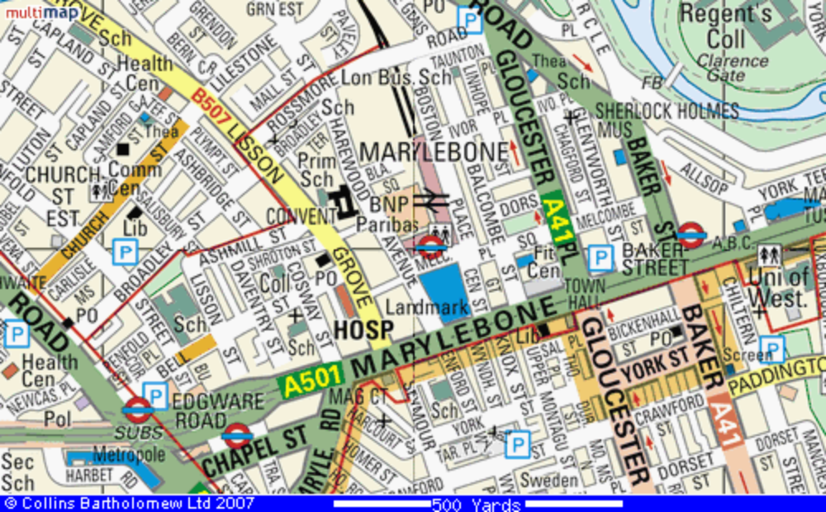

Map:
http://www.streetmap.co.uk/newmap.srf?x=527669&y=182369&z=0&sv=NW1+4SH&st=2&pc=NW1+4SH&mapp=newmap.srf&searchp=newsearch.srf

